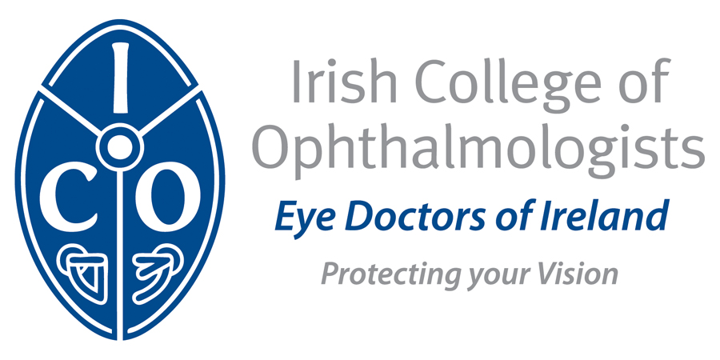



Irish College of Ophthalmologists/Novartis RESEARCH Award 2015-2016

The ICO/Novartis Research Award for 2015-2016 will be awarded to a project selected by a panel of experts *. A call is now made for applications for this bursary. Please give a summary of your proposed project in the format suggested on this form and return it electronically to Mr Jeremy O Connor, Chairman Scientific & Yearbook Committee, Irish College of Ophthalmologists, at siobhan.kelly@eyedoctors.ie before 7th September, 2015. The application should be accompanied by a full curriculum vitae and a detailed plan of the research which you intend to carry out. The prize is not restricted to eye doctors in training and those in practice are encouraged to consider making a suitable application. Applicants must hold a medical degree. The applications received will be shortlisted and a panel of experts, to include an extern, will interview those shortlisted to determine the winner. The interviews are expected to take place during the week beginning September 21st.

The research proposal should be accompanied by;
1. A letter of endorsement by the principal investigator
2. A letter confirming appropriate infrastructure from the Head of Department where the research is being carried out.

Deadline for receipt of applications: Monday 7th September, 2015

Please return a detailed plan of the research project and full Curriculum vitae to:

Please return completed forms electronically to
Mr Jeremy O Connor,
Chairman, Scientific & Yearbook Committee
Irish College of Ophthalmologists
siobhan.kelly@eyedoctors.ie

* Please note that the recipient of the research award must be available to present an update on their research at the ICO Annual Conference in 2016 and that the project must be carried out in an unfunded research post.

Application Guidelines

Irish College of Ophthalmologists/Novartis Research Award 2015-16

The following are application guidelines for the ICO/Novartis Research Award. Please provide details in relation to each point as indicated below.

Name:
Address for correspondence:
Telephone No.:
Fax No.:
Email address:

Research Project Title:
Location:
(Institute(s) / Center(s) within which the project will be based)
Planned Duration:
(Broad start/finish timelines for the completion of the project)

Project Rationale / Objectives:
(This should begin with a current review of the research area in question, followed by a detailed outline of the research objectives proposed within the project.)

Project Details:
(All relevant details regarding protocols to be employed in the project
(e.g. inclusion/exclusion criteria, interventions, endpoint assessments, ethics / regulatory approvals etc) should be included.)

Publication Plan:
(Details of target Ophthalmology journals / submission dates should be included where appropriate.)

Financial Cost Breakdown:
(A detailed breakdown of the financial costs involved in the project (e.g. material costs / laboratory costs / travel / sundries etc) should be included.)

The research proposal should be accompanied by;
1. A letter of endorsement by the principal investigator
2. A letter confirming appropriate infrastructure from the Head of Department where the research is being carried out.

