SAVE THE DATE
OPHTHALMIC POSTGRADUATE TEACHING PROGRAMME 2017-2018.

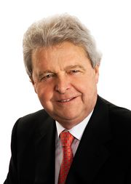

Mr Peter Barry Memorial Lecture
Thursday 14th December 2017, 5-7pm

Chair: Mr. Dara J. Kilmartin MSc, FRCSI, FRC Ophth, EBOD, Consultant Ophthalmologist and Vitreoretinal Surgeon.
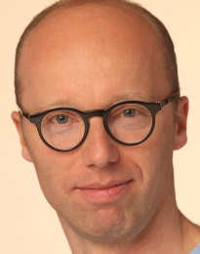
Guest Speaker:

Professor Oliver Findl, MD MBA FEBO
Chief, Dept of Ophthalmology, Hanusch Hospital Vienna/
ESCRS Board Member
Head and founder of the Vienna Institute for Research in Ocular Surgery (VIROS).
'Lens surgery and retinal detachment: risks and prophylaxis'.

Venue: Education & Conference Centre, Royal Victoria Eye & Ear Hospital.

This meeting is kindly sponsored by:
Refreshments will be available from 4.30. The meeting will begin at 5pm sharp

