“Anatomy and Art”
Professor Clive Lee,
Professor of Anatomy, Royal College of Surgeons in Ireland
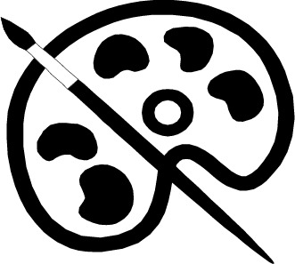
Thursday, 28th May 2015 (5-6pm)
Education & Conference Centre, RVEEH

This meeting is open to all, refreshments available from 4.30pm
This meeting will not be video-linked.
For further details please contact Una Nugent or Dr Denise Curtin.

