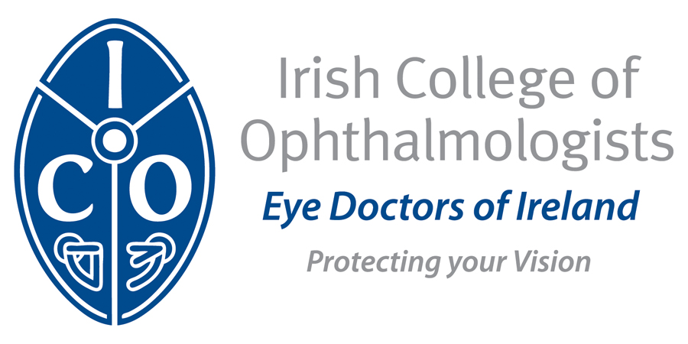

Abstract Entry Form ICO Annual Conference 2016
Europe Hotel, Killarney 18th-20th May

Category: Paper □ Poster □

Title:

Authors: (Surname First, followed by initial without titles or degrees)

Affiliation:

Objectives:

Methods:

Results:

Conclusions:

Please submit by e-mail to siobhan.kelly@eyedoctors.ie
Deadline for receipt of Abstracts: Monday 14th March, 2016

