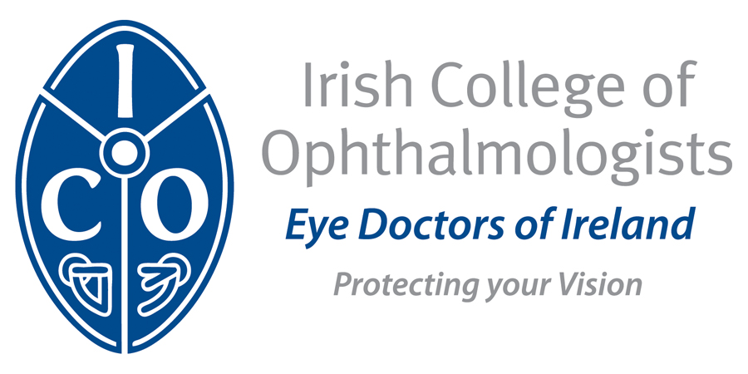

Annual Conference 2016
Europe Hotel, Killarney
Wednesday 18th to Friday 20th May, 2016

REGISTRATION FORM
Personal Details
Name

Address

Telephone

Email

Schedule of Conference Fees
Category | Early Fee | Late Fee(after May 13th)
ICO Members | €400 | €450
Non ICO Members | €600 | €650
NCHDs | €400 | €400
Gala Dinner | €100 | €100

* There is no Registration fee for retired ICO members
* Funding is available to cover registration fee for ICO trainees and those NCHDs on the CPD Support Scheme – please contact Siobhan
* The Conference fee includes dinner on Thursday 19th May in the Europe Hotel

Accommodation Package
A conference accommodation rate has been negotiated for rooms at the Hotel Europe, please contact the hotel directly

The Europe Hotel & Resort, Fossa Killarney
Phone:(064) 667 1300

Member of College rate
Golfside Rooms @ €170 per night single occupancy (€190 double/twin)
Or
Lakeview Rooms @ €190 per night single occupancy (€210 double/twin)

Total Amount Due
Registration Fee; _________________

ICO Annual Membership*; _________________

Extra Dinner Tickets; ____________________

Total; ____________________

* Members must have paid the annual subscription fee to participate in the Annual general meeting which will be held on Thursday 19th May, 2016

Payment Methods
Payment by cheque, bank transfer or credit/debit card;
Please make cheques payable to the Irish College of Ophthalmologists
Credit Card: Visa □ Mastercard □

Credit Card Number: _______/_________/________/_______

Expiry Date: ___________/____________

Security Code: ______________last three digits on the back of your card

Signature: _________________________________

Date: ______________

Wire Transfer Details:
IBAN IE67BOFI90008430285887
A/c Number 30285887
Bank Code 90-00-84
Bank Swift Code BOFIIE2D

Please Return before Monday 2nd May to
Annual Conference, Irish College of Ophthalmologists
121 St. Stephens Green, Dublin 2
Tel: + 353 1 402 2777 info@eyedoctors.ie www.eyedoctors.ie

