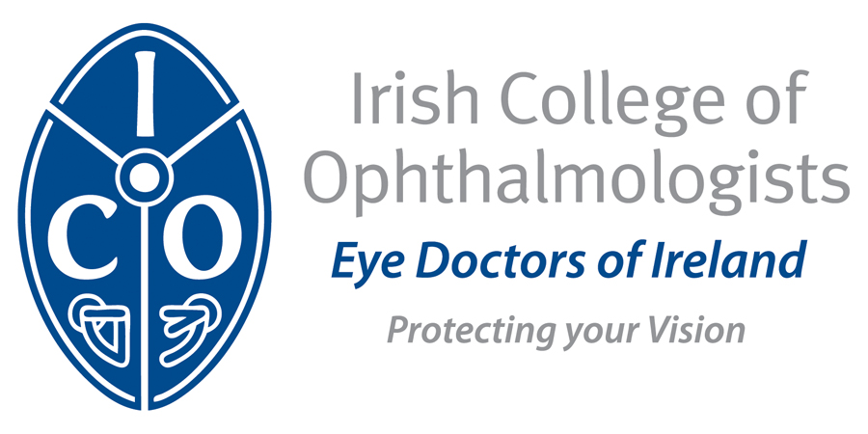

Annual Conference 2016
Slieve Russell Hotel, Cavan
Wednesday 17th to Friday 19th May, 2017

REGISTRATION FORM
Personal Details
Name

Address

Telephone

Email

Schedule of Conference Fees
Category | Early Fee | Late Fee(after May 12th)
ICO Members | €400 | €450
Non ICO Members | €600 | €650
NCHDs | €400 | €400

* There is no Registration fee for retired ICO members
* Funding is available to cover registration fee for ICO trainees and those NCHDs on the CPD Support Scheme – please contact Siobhan
* The Conference fee includes evening events on Wednesday 17th and Thursday 18th in the Hotel

Accommodation Package
A conference accommodation rate has been negotiated for rooms at the Slieve Russell, please contact the hotel directly

Slieve Russell Hotel, Golf & Country Club
Ballyconnell, Co.Cavan.
Phone:+353 49 952 6444

Conference Delegate Rate rate
€65 per person sharing per night B&B
€85 for single occupancy per night B&B

Total Amount Due
Registration Fee: _________________

ICO Annual Membership*: _________________

Extra Dinner Tickets: ____________________

Total: ____________________

* Members must have paid the annual subscription fee to participate in the Annual general meeting which will be held on Friday 19th May, 2017

Payment Methods
Payment by cheque, bank transfer or credit/debit card
Please make cheques payable to the Irish College of Ophthalmologists
Credit Card: Visa □ Mastercard □

Credit Card Number: _______/_________/________/_______

Expiry Date: ___________/____________

Security Code: ______________last three digits on the back of your card

Signature: _________________________________

Date: ______________

Wire Transfer Details:
IBAN IE67BOFI90008430285887
A/c Number 30285887
Bank Code 90-00-84
Bank Swift Code BOFIIE2D

Please Return before Monday 1st May to
Annual Conference, Irish College of Ophthalmologists
121 St. Stephens Green, Dublin 2
Tel: + 353 1 402 2777 info@eyedoctors.ie www.eyedoctors.ie

