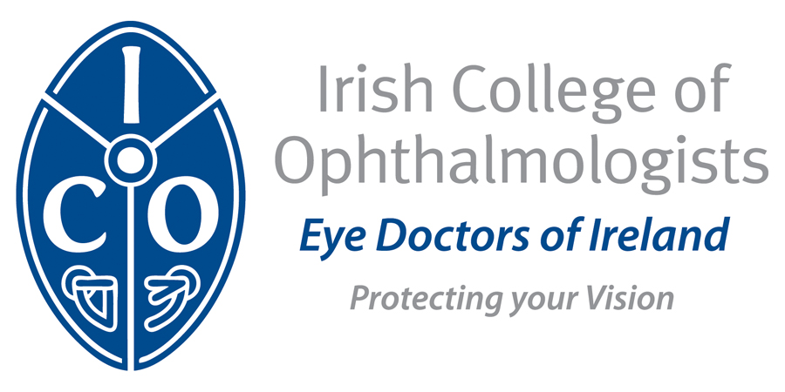

Annual Conference 2017
Slieve Russell Hotel, Cavan
May 17th to 19th, 2017

EXHIBTION STAND DETAILS

Company Details
Name

Address

Telephone

Email

Names of Company Representatives Attending

Accommodation:
Group rate - Request a room from the ICO exhibitors’ room block

Exhibitor Rate & agreed group rate:
€65 per person sharing per night B&B
€85 for single occupancy per night B&B

Price per Stand
• Price per Stand for the 2016 Conference is €2,250

Set up from 2pm on the afternoon of Tuesday 16th May, 2017

For further information please contact Siobhan Kelly
siobhan.kelly@eyedoctors.ie

Financial support from pharmaceutical and instrument companies is being sought to help with the costs associated with the educational content of the meeting. Supporting companies will have no input into the scientific programme or speakers and will be exhibiting only.

