Joint Irish & UKISCRS
Refractive Surgery Meeting
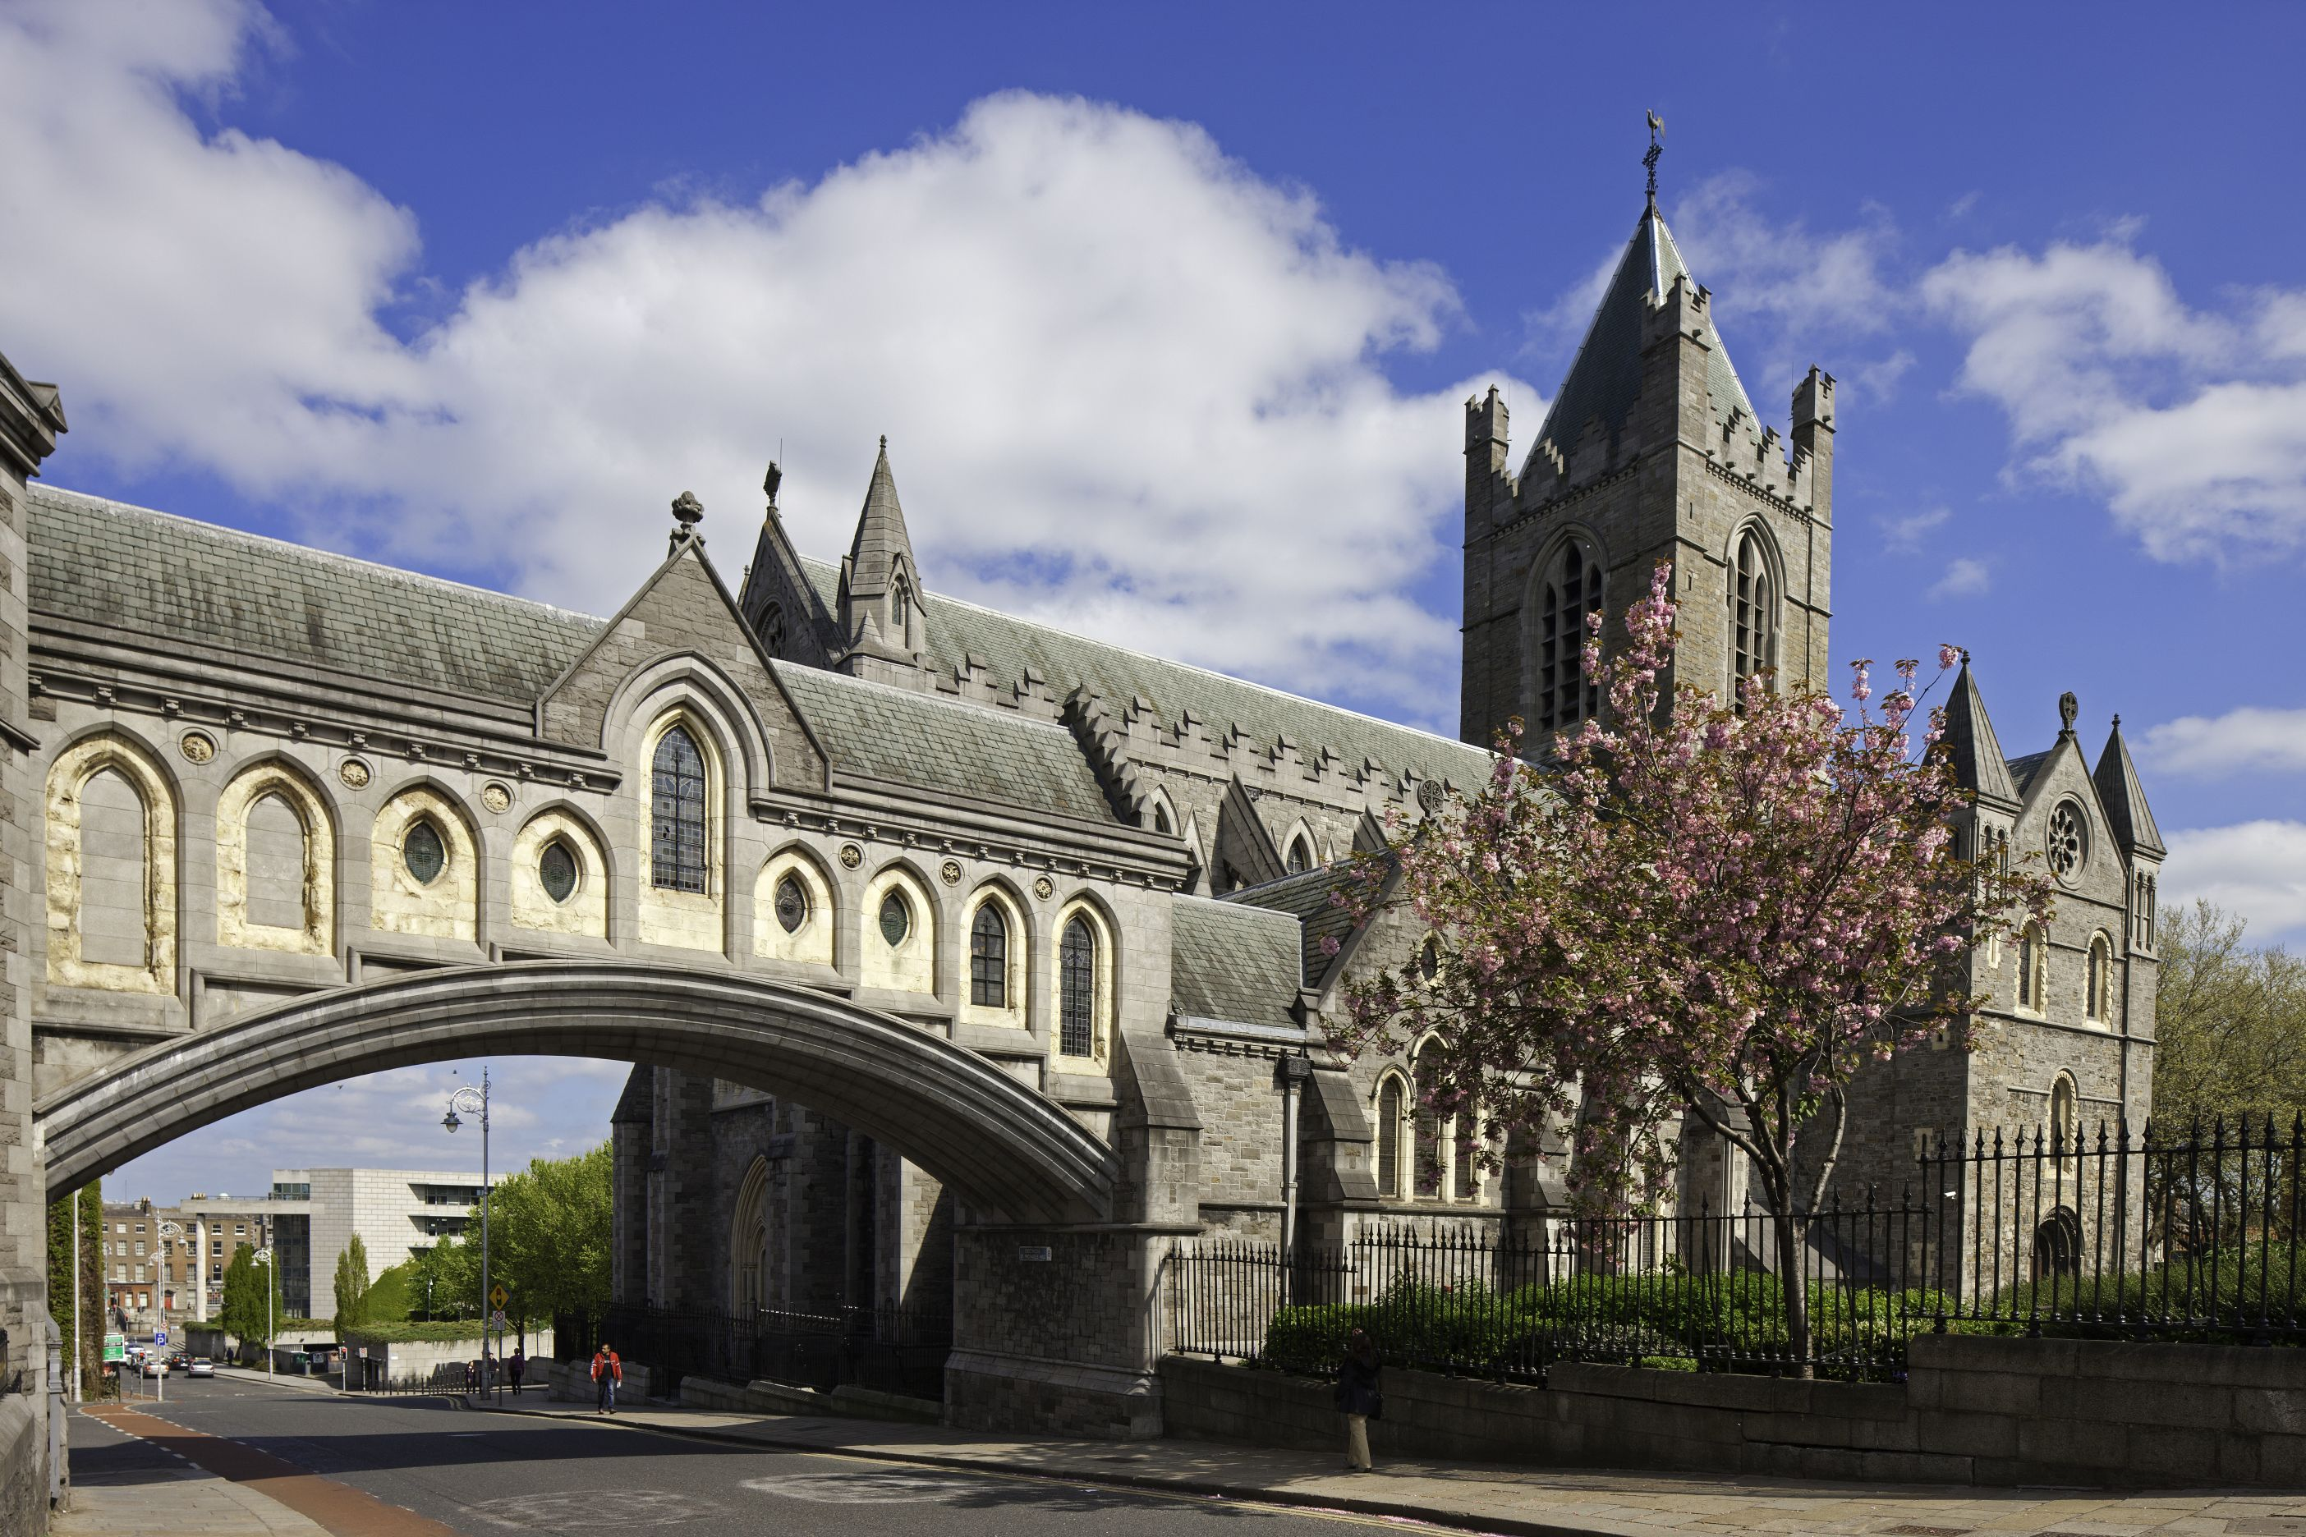
Friday 2nd December 2016
The Gibson Hotel, Dublin

Programme

Friday 2nd December 2016

Registration 8am - 8.45am

Start 9am

0900-0920 Capsulotomy, Past, Present & Future
Richard Packard

0920-0940 Multifocals
Rizwana Khan

0940-1000 Epithelial remodelling
Samer Hamada

1000-1020 Logistics and ergonomics with mobile Femtosecond laser for cataract surgery
Mayank Nanavaty

1020-1045 COFFEE

1045-1105 'Little Surgical e-LfHs'
Philip Bloom

1105-1125 COMET/MEET for Stem Cell Deficiency
Samer Hamada

1125-11.45 In the bag IOL fixation in the presence of a PC tear
Brian Little

1145 Introduction to Tom Casey Memorial Lecture Michael O’Keeffe

1150-1230
Tom Casey Memorial Lecture
Corneal transplantation in 2016: changing trends and impact of surgeon learning on outcomes
Frank Larkin

1230-1330 LUNCH

1330-1410
Dermot Pierse Memorial Lecture
IOL Exchange: Why, When and Where

Brian Little

1410-1430 Small Aperture IOL - A new option for treating Presbyopia
Sathish Srinivasan

1430-1450 Use of the Femtosecond laser for complex corneal and anterior segment surgery
Sheraz Daya

1450-1510 Cross Linking for Corneal Ectasia
Dr Muhammad Yasir Arfat

CASE PRESENTATION

1600-1630 Summary, questions and close

Coffee

