Route 1 – Via Science Gallery Entrance, Pearse St
Most direct route for those coming from the Chartered Accountants House reception – 3 min walk
- Enter the Pearse St entrance at the Science Gallery – (Fig 1)
- Continue straight, passing The Lloyd Institute Building on right
- Turn right after The Lloyd Building – (Fig 2)
- Continue straight, then take first left at Physiology Building
- Continue straight, walking towards side of Chemistry Building & veering right at the entrance to Faculty of Health Sciences
- Take immediate left to arrive at front of Chemistry Building (Fig 5)
- The Old Anatomy Lecture Theatre is housed in the Chemistry Building. You will be greeted here and directed to the theatre.

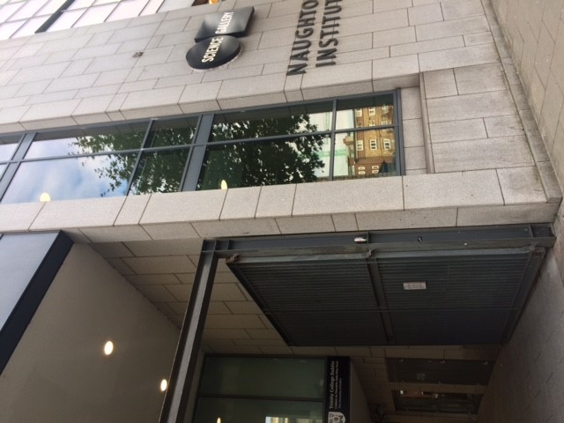
Fig 1 Science Gallery Entrance on Pearse St
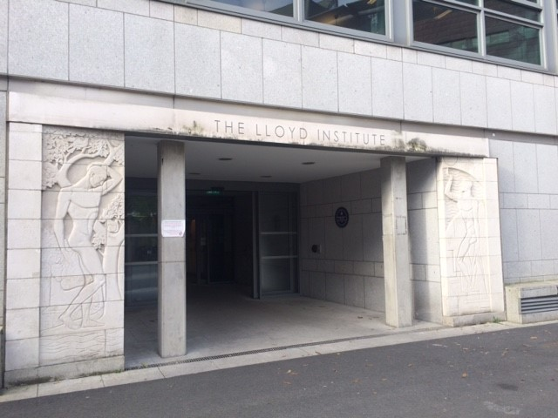
Fig 2 The Lloyd Institute

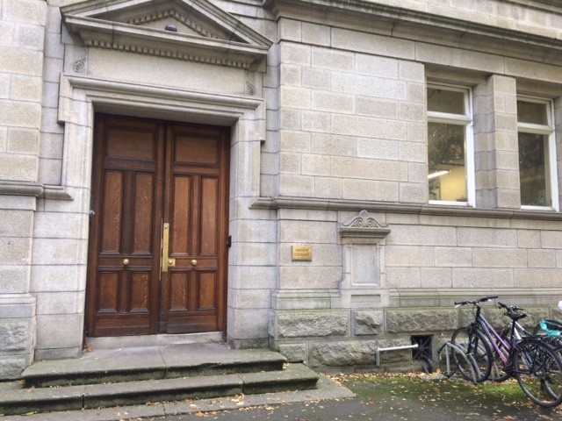
Fig 5 – Entrance to Chemistry Building

Route 2 – Via Nassau Street Pedestrian Gate
- Enter TCD Campus via Nassau Street Pedestrian Gate. The gate is “in the wall” opposite the Trinity Point Building (far end of Nassau St close to National Gallery end of Nassau St)
- Walk down steps, continue straight and Chemistry Building is on your right.

Route 3 – Via Lincoln Gate
- Enter Lincoln Gate on Lincoln Place
- Take first left.
- Walk towards pedestrian crossing
- The Chemistry Building is on the right
- Turn right at pedestrian crossing to main entrance to Chemistry Building.

