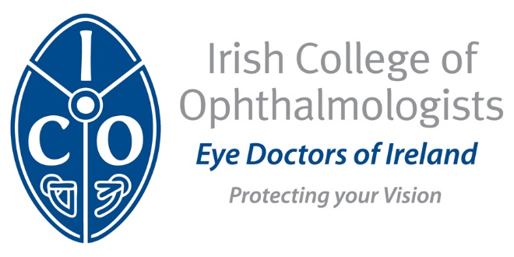

Irish College of Ophthalmologists/Novartis Eye Research Bursary 2019-2020

The ICO/Novartis Eye Research Bursary for 2019-2020 will be awarded to a project selected by a panel of experts*.

A call is now made for applications for this bursary. Please give a summary of your proposed project in the format suggested on this form and return by email to Mr John Doris, Chairman Scientific Committee, Irish College of Ophthalmologists, at siobhan.kelly@eyedoctors.ie.

The closing date for submissions is Monday, 28th October, 2019. The application should be accompanied by a full curriculum vitae and a detailed plan of the research which you intend to carry out. The prize is not restricted to eye doctors in training and those in practice are encouraged to consider making a suitable application. Applicants must hold a medical degree. The applications received will be shortlisted and a panel of experts, to include an extern, will interview those shortlisted to determine the winner. The interviews are expected to take place during the week beginning November 11th.

The research proposal should be accompanied by;
1. A letter of endorsement by the principal investigator
2. A letter confirming appropriate infrastructure from the Head of Department where the research is being carried out.

Deadline for receipt of applications: Monday 28th October, 2019

Please return a detailed plan of the research project and full Curriculum vitae by email to:

Mr John Doris, Chairman, Scientific & Continuing Professional Development Committee, Irish College of Ophthalmologists
siobhan.kelly@eyedoctors.ie

* Please note that the recipient of the research award must be available to present an update on their research at the ICO Annual Conference 2020 which will take place in Lyrath Hotel (13th – 15th May 2020) and that the project must be carried out in an unfunded research post.

Application Guidelines

ICO/Novartis Eye Research Bursary 2019-20

The following are application guidelines for the ICO/Novartis Eye Research Bursary. Please provide details in relation to each point as indicated below.

Name:
Address for correspondence:
Telephone No.:
Fax No.:
Email address:

Research Project Title:
Location:
(Institute(s) / Center(s) within which the project will be based)
Planned Duration:
(Broad start/finish timelines for the completion of the project)

Project Rationale / Objectives:
(This should begin with a current review of the research area in question, followed by a detailed outline of the research objectives proposed within the project)

Project Details:
(All relevant details regarding protocols to be employed in the project e.g. inclusion/exclusion criteria, interventions, endpoint assessments, ethics / regulatory approvals etc) should be included)

Publication Plan:
(Details of target Ophthalmology journals / submission dates should be included where appropriate.)

Financial Cost Breakdown:
(A detailed breakdown of the financial costs involved in the project (e.g. material costs / laboratory costs / travel / sundries etc) should be included.)

The research proposal should be accompanied by;
1. A letter of endorsement by the principal investigator
2. A letter confirming appropriate infrastructure from the Head of Department where the research is being carried out.

