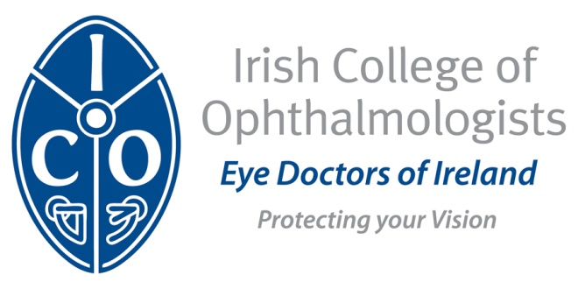

Entry into Training in Medical Ophthalmology MT4
Those who have successfully completed MT1 to MT3 can proceed to compete to enter the fourth year of training provided they meet the minimum criteria outlined below. Applicants are also required to understand and provide evidence of their suitability to become a medical ophthalmologist at specialist registration level.

Entry to the MT4 programme is by competitive interview held centrally at the ICO. The scorecard for entry into MT4 outlines the allocation of marks for each competency.

Criteria for entry into MT4 Training in Medical Ophthalmology
1. Successful completion of MT1, MT2, MT3.
2. Satisfactory CAPA appraisals for each 6 months of the first 3 years.
3. Satisfactory achievement of all summative WBAs at each competency point.
4. Successful completion of the MRCSI Examination.
5. Successful completion of the Human Factors (HF) Examination (see Appendix C).
6. Documented attendance at obligatory ICO courses.
7. A validated logbook to include:
150 intravitreal injections
20 panretinal lasers and 5 macular lasers.
10 YAG capsulotomy lasers, 5 YAG laser PIs
20 minor procedures (S+P, I+C, lesion excision and biopsy etc)
5 ectropion
Refraction x 30 cases

8. Clinical cases logbook for entry into MT4 to include:
1 managed case of glaucoma: POAG, NTG or OHT
1 managed case of uveitis: Anterior or posterior
1 managed case of ARMD : Wet or dry ARMD
1 managed cases of CRVO: Ischaemic or non- ischaemic
1 managed cases of childhood strabismus: Esotropia or exotropia
3 managed cases of acquired strabismus: IV x 1, VI x 1, III CR N palsy x 1
2 managed cases of neuro-ophthalmology: CSF/GCA/ Horners
2 managed cases of anterior segment: Herpetic and microbial keratitis

- Audits / QI project.

SCORECARD for ENTRY into MT4

A.
Performance during Core Ophthalmology Training: 650 marks

1.Workplace Based Assessments 300 marks

1a. Clinical cases and procedural assessments

1b. Proedural and Clinical Cases Logbook

1c. Audit Presentations

2. ICO Assessments 350 marks

2a. School for Ophthalmology Assignments 100

2b. Human Factors OSCEs 100

2c. MRCSI Ophth Examination 150

B.
Specialty Interview: (5 x 70 marks) 350 marks

B1. Quality and Safety in Medical Ophthalmology Healthcare

B2. Commitment to Academic Advancement and Lifelong Learning

B3. Knowledge of Current Issues relevant to Medical Ophthalmology Practice

B4. Decision Making in Medical Ophthalmology

B5. Professionalism and Probity in Medical Ophthalmology Practice

NB: This scorecard may undergo further minor modifications with minor redistribution of marks within section A and B. Trainees will be updated of any major changes, should they occur, in a timely manner.

