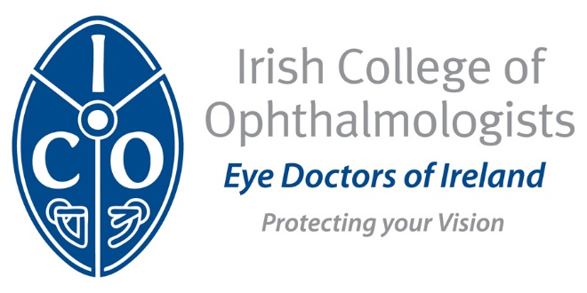

Irish College of Ophthalmologists
Continuing Professional Development – Support Scheme
Application Form

Further Information Available - https://www.eyedoctors.ie/trainees/CPD_Support_Scheme.asp
* Please refer to the HSE publication on the CPD Support Scheme to confirm your eligibility

NAME

IMC NUMBER

HOSPITAL

POST – Reg or SHO
Are you enrolled on a Professional Competence Scheme
Email

Telephone

The ICO uses your contact information to keep you informed about courses and meetings we are running for ongoing professional education

