**ICO IRISH COLLEGE OF OPHTHALMOLOGISTS**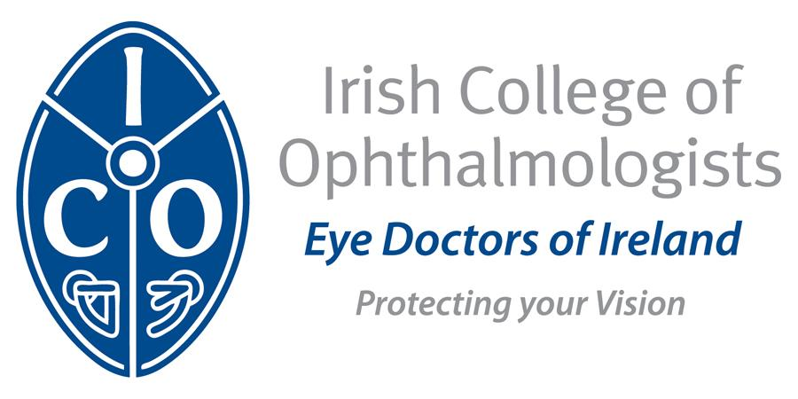

GUIDE TO THE RECOGNITION OF

EVENTS OR ACTIVITIES FOR CPD

**Professional Competence Scheme**

The Medical Practitioners Act 2007 places a statutory obligation on all registered Medical Practitioners to maintain their professional competence by participating in recognised Professional Competence Schemes. The ICO has been accredited by the Medical Council of Ireland (MCIRL) as an approver and provider of CPD activities and as such must comply with the Medical Council’s Institutional Governance Criteria and the Standards for Integrity and Independence. From 2026, it is a Medical Council requirement that the ICO obtain financial disclosures from all persons involved in the design and delivery of a CPD event. This requirement has been introduced by the Medical Council to safeguard against bias in further education.

This guide has been prepared to help individuals who are seeking CPD recognition from the ICO for educational events.

**What activities require recognition for CPD?**

* **Planning CPD**: This is a self directed category and CPD recognition is not required
* **Practice Review:** Prospective CPD recognition is not required
* **Work-Based Learning:** This is a self directed category and CPD recognition is not required
* **Accredited Continuing Education (CE) (minimum of 20 credits required)**

Accredited CE activity includes attendance at relevant educational events, conferences, courses, and workshops at local, national, international level. CE activity must be accredited in Ireland or in the State where it is delivered. Some examples include:

* Local, Regional, National, International accredited meetings
* Conferences/Seminars/Webinars. Presentations to scientific meetings
* Training Bodies, College, Medical Societies
* Education, Training and Simulation Programmes
* Courses, workshops, seminars, diplomas
* Online learning courses, modules, workshops
* Masterclass series also webcast
* Relevant academic qualification (degree, diploma, course)

**What activities may not be recognised for CPD?**

Some events include, for instance, an AGM and dinner as well as an academic meeting. Please note the following activities will not be counted as educational time for the purposes of CPD.

Registration time, breaks, lunch or dinner, announcements and so on are not eligible for CPD recognition.

Activities organised primarily to promote a product or service or which might be deemed as promotional are not eligible for consideration for CPD recognition.

**Criteria for recognition of CPD events**

Event must:

* Address educational needs of the targeted specialty
* Be free from commercial bias
* Have doctors from the targeted specialty participating in the planning process
* Be of relevance to the pursuit of the targeted specialty’s clinical, educational, research and other professional activity
* Clearly state learning objectives in specific, observable and measurable terms:
  + Learning objectives are matched by the content and teaching, thus based on the principles of adult learning**.**
  + Learning objectives should use action verbs such as “evaluate”, “identify”, “review” etc.
  + Learning objectives should include clear description of those for whom the event is primarily intended
  + Details about what the event hopes to achieve, and how this will be put into practice
* Be of an appropriate standard for a specialist in the targeted specialty
* Need not to be confined solely to medical topics and improvements in patient care but can also include additional topics such as management, medical ethics.
* Content demonstrates high clinical and ethical standards
* Include a mechanism for evaluation and feedback on the relevance, quality and effectiveness of the activity and to determine how well the learning objectives have been met.
* Provide publicity material containing a clear description of those for whom the event is primarily intended.
* Have a nominated organiser who will keep records of attendance and evaluation**.**
* Presentations must not contain promotional content

*Please note:*

* Question and answer sessions are eligible for credit
* The evaluation criteria as outlined above, are applied to each module/session within a programme.
* Wording such as “Applied for CPD recognition” or “CPD Recognised” as appropriate may be used in material associated with the event

**Credits & Reciprocity**

* A CPD certificate of attendance for an event or activity granted by one Postgraduate Training Body or Faculty, will be automatically accepted by the other Postgraduate Training Bodies or Faculties as evidence of a doctor's participation in that activity.  Event organisers should apply for CPD recognition to the Postgraduate Training Body / Faculty most relevant to the content of the event or activity.  An application for CPD recognition for an event need only be made to one of the Postgraduate Training Bodies / Faculties
* 1 hour of education = 1 CPD credit
* Half credits issued after 1 full hour of activity

**Pharmaceutical/Medical Device Sponsorship**

* Events funded by a single pharmaceutical company must have an independent organising committee and adhere to all guidelines as outlined below. Wherever possible, sponsorship should be obtained from more than one company to avoid the perception of undue influence or favouritism.
* It is acceptable for the funding source to restrict donated funds to certain elements of a program, e.g. speaker costs, travel, refreshments or materials.
* Educational component of any meeting should be standalone and should not be exclusively related to any company or product promotion.
* Only unrestricted educational and research grants are acceptable
* Where there is a contribution from a pharmaceutical company, medical device company or other commercial interest this should be clearly stated
* All promotional activity should be confined to the exhibition area
* Pharmaceutical representatives should not speak or present during the educational component of the meeting.
* Where events are industry funded it is important that the nature of the relationship between sponsor and individual speakers is clarified
* All paid speakers (and speakers with any other conflicts) should have a conflict of interest slide in their presentation that indicates the nature of their conflict.
* Information with regard to honoraria or speaker contracts may occasionally be requested and considered as part of the evaluation for CPD recognition.
* Slides may not have a company logo

**Procedure for Recognition**

Organiser submits:

* A [CPD Recognition Application Form](https://docs.google.com/forms/d/e/1FAIpQLSfXRCt-qYStYJksacoK1BV02Mzh69g3e4HC29JkrL995qKsjQ/viewform?usp=sharing&ouid=112667379725996337870)
* Supporting documentation as outlined on the application form
* The event organiser completes a Financial Disclosure Form and shares the form with all persons involved in the event
* Fee (where applicable)
* The application must be submitted at least **4 weeks** in advance of the meeting. Retrospective applications will not be considered.
* When the event is finished, the organiser issues certificates of attendance to delegates who have signed the register. A copy of the register is forwarded to the ICO.

**Financial Disclosure Declaration Form**

Many healthcare professionals have financial relationships with ineligible companies. The Medical Council defines ***“ineligible companies” as those whose primary business is producing, marketing, selling, re-selling, or distributing healthcare products used by or on patients***.

The ICO is responsible for identifying relevant financial relationships between individuals in control of educational content and ineligible companies and managing these to ensure they do not introduce commercial bias into the education. Financial relationships of any amount are defined as relevant if the educational content is related to the business lines or products of the ineligible company. To comply with the Medical Council’s standards and criteria, the ICO is required to collect a financial disclosure form from any person involved in the design and/or delivery of a CPD event.

[**Click here to complete the Financial Disclosure Declaration Form**](https://forms.gle/rUKkL4dSErPqZ9TP8)

It is the **responsibility** of the **event organise**r to ensure that this form is shared with and completed by all those involved in the event. Failure to do so may result in the event not being approved for CPD by the ICO.

***Both the CPD event application and any financial declarations will be reviewed by the ICO which may in some instances require a more detailed review of event content.***

**Contact Information**

If you have any questions relating to the ICO Professional Competence Scheme or the associated forms, please contact: Siobhan Kelly [siobhan.kelly@eyedoctors.ie](mailto:siobhan.kelly@eyedoctors.ie)