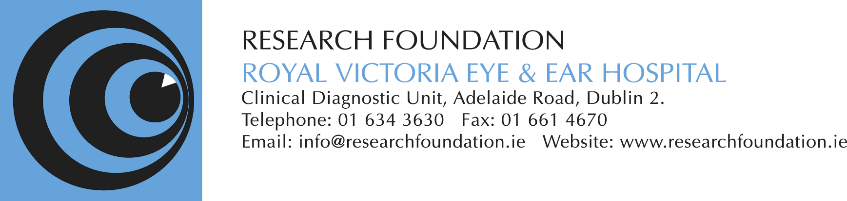
15th June 2017 ‘New Frontiers in Ophthalmology’ PROGRAMME

8.15 – 8.45 Registration - tea and coffee
8.45 – 8.50 Welcome and Introduction by Chair Mr. Noel Horgan
8.50 - 9.05 Professor Susan Kennedy
‘The Enigma of Uveal Melanoma – Part 1’
9.05 – 9.20 Dr Fiona Roberts
‘The Enigma of Uveal Melanoma - Part 2’
9.20 – 9.30 Questions

9.30 - 9.50 Dr Arun Singh
‘Diagnosis of Uveal Melanoma - Pearls and Pitfalls’
9.50 - 10.00 Questions

10.00 - 10.20 Professor Heinrich Heimann
‘Treatment Choices in Uveal Melanoma’
10.20 - 10.30 Questions
10.30 - 10.45 Tea & coffee break
10.45 - 11.05 Dr Arun Singh
‘Genetics of Uveal Melanoma: Recent Advances in our Understanding’
11.05 - 11.15 Questions

11.15 - 11.35 Professor Heinrich Heimann
‘Fine Needle Biopsy in Uveal Melanoma, Pros and Cons’
11.35 -11.45 Questions

11. 45 – 12.00 Guest Speaker from Pharmaceutical Company to be confirmed
Title of presentation to be confirmed

12.00 - 12.20 Professor Giuseppe Gullo
‘Survival in Uveal Melanoma: An Irish Patient Cohort’
12.20 -12.30 Questions

12.30 – 12.50 Professor John Crown
‘Systemic Treatment for Uveal melanoma in the 21st Century’
12.50 - 1.00 Questions
1.00 – 2.00 Lunch

