**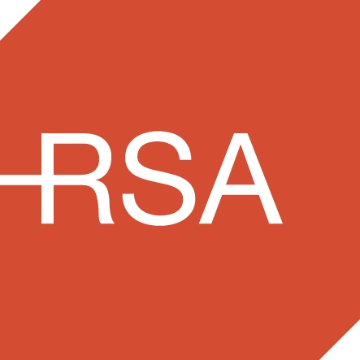**

National Office for Traffic Medicine

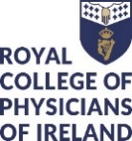

Certificate

Road Safety

Mobility and Health

|  |  |  |  |  |  |
| --- | --- | --- | --- | --- | --- |
| **W:\Traffic Medicine\communications\logos\1.jpg** | **W:\Traffic Medicine\communications\logos\2.jpg** | **W:\Traffic Medicine\communications\logos\4.jpg** | **W:\Traffic Medicine\communications\logos\6.jpg** | W:\Traffic Medicine\communications\logos\RSA_distracted_large.jpg | **W:\Traffic Medicine\communications\logos\_ZAP7697.jpg** |

**Target audience**

All road safety stakeholders

**Cost: €400**

**Places are limited**

**www.rcpi.ie/trafficmedicine | Email notm@rcpi.ie | Phone 01 863 9788**

**Contents**

[**Who should consider doing this Certificate?** 3](https://rcpi-my.sharepoint.com/personal/margaretryan_rcpi_ie/Documents/Education/2.%20Certificate%20in%20Road%20Safety,%20Mobility%20&%20Health/Cert%20RSM&H%20Autumn%202018/RSM&H%20Course%20Outline%20Autumn%202018.docx#_Toc522518180)

[**Learning how to apply Road Safety Effectiveness** 3](https://rcpi-my.sharepoint.com/personal/margaretryan_rcpi_ie/Documents/Education/2.%20Certificate%20in%20Road%20Safety,%20Mobility%20&%20Health/Cert%20RSM&H%20Autumn%202018/RSM&H%20Course%20Outline%20Autumn%202018.docx#_Toc522518181)

[**Certificate in Road Safety, Mobility and Health** 4](#_Toc522518182)

[**Online Content** 4](#_Toc522518183)

[**Module 1**  **Road Safety, the Broader Picture** 4](#_Toc522518184)

[Part 1 Road Safety – How are we performing? 4](#_Toc522518185)

[Part 2 Road Safety in Ireland – A Multi-Agency Approach 4](#_Toc522518186)

[Part 3 Human Factors and Road Safety 4](#_Toc522518187)

[**Module 2**  **Driving Assessment, Rehabilitation & Adaptive Processes** 4](#_Toc522518188)

[Part 1 Assessment of Fitness to Drive 4](#_Toc522518189)

[Part 2 Rehabilitation and Adaptive Processes 4](#_Toc522518190)

[**Module 3**  **Strategies to Improve Road Safety** 5](#_Toc522518191)

[Part 1 Education and Awareness 5](#_Toc522518192)

[Part 2 Engineering Measures 5](#_Toc522518193)

[Part 3 Enforcement Measures 5](#_Toc522518194)

[**Certificate in Road Safety, Mobility and Health** 6](#_Toc522518195)

[**Provisional Workshop Timetable** 6](#_Toc522518196)

[SPEAKER BIOGRAPHIES 7](#_Toc522518197)

[*Professor Des O’Neill* 7](https://rcpi-my.sharepoint.com/personal/margaretryan_rcpi_ie/Documents/Education/2.%20Certificate%20in%20Road%20Safety,%20Mobility%20&%20Health/Cert%20RSM&H%20Autumn%202018/RSM&H%20Course%20Outline%20Autumn%202018.docx#_Toc522518198)

[*Dr Declan Bedford* 7](https://rcpi-my.sharepoint.com/personal/margaretryan_rcpi_ie/Documents/Education/2.%20Certificate%20in%20Road%20Safety,%20Mobility%20&%20Health/Cert%20RSM&H%20Autumn%202018/RSM&H%20Course%20Outline%20Autumn%202018.docx#_Toc522518199)

[**Professor Ciaran Simms** 8](https://rcpi-my.sharepoint.com/personal/margaretryan_rcpi_ie/Documents/Education/2.%20Certificate%20in%20Road%20Safety,%20Mobility%20&%20Health/Cert%20RSM&H%20Autumn%202018/RSM&H%20Course%20Outline%20Autumn%202018.docx#_Toc522518200)

[*Associate Professor, Mechanical & Manufacturing Engineering* 8](https://rcpi-my.sharepoint.com/personal/margaretryan_rcpi_ie/Documents/Education/2.%20Certificate%20in%20Road%20Safety,%20Mobility%20&%20Health/Cert%20RSM&H%20Autumn%202018/RSM&H%20Course%20Outline%20Autumn%202018.docx#_Toc522518201)

# **RCPI Certificate in Road Safety, Mobility and Health**

This blended learning course includes online tuition, a face-to-face workshop and an online Multiple-Choice Question exam.

## Course details

The Certificate in Road Safety, Mobility and Health will be awarded based on the completion of all components of the course, which take approximately 14 hours to complete. This blended learning course includes online tuition, a face-to-face workshop and an online Multiple-Choice Question exam.

|  |  |  |
| --- | --- | --- |
| **Pre-Course Videos** | **Workshop** | **Post-Course Examination** |
| Online (5 hrs.) | One-Day (7 hrs.) | Online (2 hrs.) |
| **Places are limited - Cost €400**  **To find out more or book online go to;**  <https://www.rcpi.ie/store/2018-certificate-in-traffic-medicine> | | |

## Proposed Timeline

**Registration Opens: August 20th**

**Online Components: Self-paced from September 3rd, 2018**

**Workshop Date: Thursday November 22nd**

**Online Exam: Self-paced November 23rd – Dec 14th**

**Registrations Close: October 31st**

## Course co-ordinator

[notm@rcpi.ie](mailto:notm@rcpi.ie)

**14 RCPI CPD credits will be awarded on completion of this course.**

# **Who should consider doing this Certificate?**

**This certificate is suitable for a broad spectrum of participants who have a stake or an interest in road safety including:**

|  |  |  |  |  |
| --- | --- | --- | --- | --- |
| *Road safety professionals* | *RSA and NDLS staff* | *Road Safety Officers* | *Traffic forensic investigators* | *Fleet managers and operations professionals* |
| *First Responders (Gardai, Ambulance, Fire services)* | ***Local authority staff*** | ***Engineers*** | ***Teachers*** | ***Healthcare professionals incl.***  ***public health medicine*** |

# **Learning how to apply Road Safety Effectiveness**

* **Pinpointing stakeholders & engagement strategies:**
* Who are the key players with responsibility for engagement in strategies to support the achievement of this target?
* **Conducting a risk analysis:**

What are the human factors that determine safety or increase risk for road users?

* **Recognising killer behaviours:**

Exactly how does speeding, alcohol, fatigue, distracted driving, failure to wear a seatbelt and other killer behaviours effect outcomes?

* **Identifying mobility challenges:**

When is medical assessment of fitness to drive required? What are the challenges of the rehabilitative process and what adaptations are available to support mobility?

* **Road safety solutions:**

What are the educational, engineering and enforcement measures that underpin a vision for enhanced road safety in the future? **

# **Certificate in Road Safety, Mobility and Health**

# **Online Content**

# **Module 1 Road Safety, the Broader Picture**

## Part 1 Road Safety – How are we performing?

* Stats in relation to fatalities and serious injuries in Ireland, Europe and globally.
* How does Ireland compare with other countries?
* What are our targets for 2020?
* **Video: Prof Des O’Neill, National Director of Traffic Medicine; Ms Moyagh Murdock CEO, RSA**

## Part 2 Road Safety in Ireland – A Multi-Agency Approach

* Overview of key players involved in road safety in Ireland.
* **Video: Garda Derek Cloughley; Ms Moyagh Murdock CEO, RSA**

## Part 3 Human Factors and Road Safety

Human behaviour is by far the largest cause of road fatalities and serious injuries.

* The Younger Driver
* Road Safety and Older People
* Vulnerable Road Users
* Fatigue and Sleep Loss
* Alcohol and Drugs
* Speeding, Distracted Driving & Other Killer Behaviours.
* **Video: Prof Des O’Neill, National Director of Traffic Medicine; Garda Derek Cloughley; Ms Moyagh Murdock CEO, RSA**

# **Module 2 Driving Assessment, Rehabilitation & Adaptive Processes**

## Part 1 Assessment of Fitness to Drive

* When is Medical Assessment of Fitness to drive required?
* What medical conditions affect driving capacity?
* What is entailed in a medical assessment, an off-road assessment by an occupational therapist and an on road assessment by a driving assessor?
* How to break bad news.
* **Video: Dr Declan Whelan, Occupational Physician; Prof Des O’Neill, National Director of Traffic Medicine**

## Part 2 Rehabilitation and Adaptive Processes

* Consequences of an Acquired Brain Injury (ABI).
* Supporting return to driving following ABI. Regaining competence and confidence. Car adaptations.
* Crash safety.

# **Module 3 Strategies to Improve Road Safety**

The achievement of Ireland’s targets for 2020 is underpinned by actions that are outlined in the three areas of Education, Engineering and Enforcement. Module III focuses on these three pillars and explores the measures that are being utilised to enable the achievement of our 2020 targets.

## Part 1 Education and Awareness

## Part 2 Engineering Measures

## Part 3 Enforcement Measures

* **Video: Garda Derek Cloughley; Ms Moyagh Murdock CEO RSA; Prof Des O’Neill, National Director of Traffic Medicine**

|  |  |  |
| --- | --- | --- |
| **Certificate in Road Safety, Mobility and Health****Provisional Workshop Timetable** | | |
| **Venue: RCPI, Setanta House, Dublin 2** | | |
| **Time** | **Content** | **Speaker** |
| **09.30-10.00** | Registration |  |
| 10.00–10.45 | Welcome  Keeping up to Date with the Science of Road Safety | Prof Des O’Neill |
| 10.45 – 11.30 | Road Safety and Impact on Public Health | Dr Declan Bedford |
| 11.30 – 11.50 | Break |  |
| 11.50– 12.30 | Traffic Psychology | Dr Michael Gormley |
| 12.30 – 13.00 | Support for People/Families of Seriously Injured and Fatalities |  |
| 13.00 –13.15 | Q&A |  |
| 13.15– 14.00 | *Lunch* |  |
| 14.00 –15.30 | Re-enactment of a Serious Collision | Garda Frank Lavin,  Garda Forensic Collision Investigator |
| 15.30-16.15 | Mechanism of Injury/ Crash Safety/Adaptive Processes | Dr Ciaran Simms |
| 16.15 -16.45 | Panel discussion |  |
| 16.45 – 17.00 | Closing remarks | Prof Des O’Neill |
|  |  |  |

# SPEAKER BIOGRAPHIES

**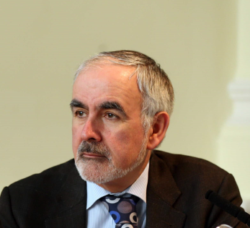**

## *Professor Des O’Neill*

**Consultant Geriatrician**

**National Programme Director** **for Traffic Medicine**

Professor Desmond O’Neill, Consultant Physician in Geriatric and Stroke Medicine at Tallaght Hospital Dublin and Trinity College Dublin and Director for the National Programme Office for Traffic Medicine RCPI/RSA.

Professor O’Neill graduated from Trinity College Dublin (TDC). He trained as a geriatrician in St James's Hospital and the University of Bristol. Following an appointment as consultant geriatrician in Selly Oak Hospital, Birmingham he returned to Dublin and currently is the senior academic in Medical Gerontology at the TCD campus at Tallaght Hospital.

His major field of research is that of transportation, ageing and older drivers. He co-chaired the RCPI Working Group on Driving and Health and has written chapters on driving and health for three international textbooks of geriatric medicine, two international textbooks of dementia care, two textbooks of medical ethics, and an Irish textbook of geriatric medicine. In addition, he was co-author of a major OECD report on transport in later life, and contributed to a similar report for the US Transportation Research Board.

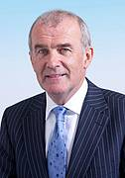

## *Dr Declan Bedford*

**Consultant in Public Health Medicine and Chair of RCPI Working Group in Traffic Medicine**

Dr Declan Bedford is a Fellow of the Faculty of Public Health Medicine of the RCPI. He worked as a Specialist in Public Health Medicine with the HSE and as Director of Public Health in the North East for seven years until his retirement from the HSE in August 2012. He now works for a number of agencies including the RCSI where his role is to support the strategic development of the RCSI Hospitals Group. He is currently chairman of the RCPI Working Group on Traffic Medicine and chairman of the Health Research Board

His published research includes research in the areas of suicide and mental health, men’s health, alcohol, injury prevention, infectious diseases, health services and utilisation of hospital services.

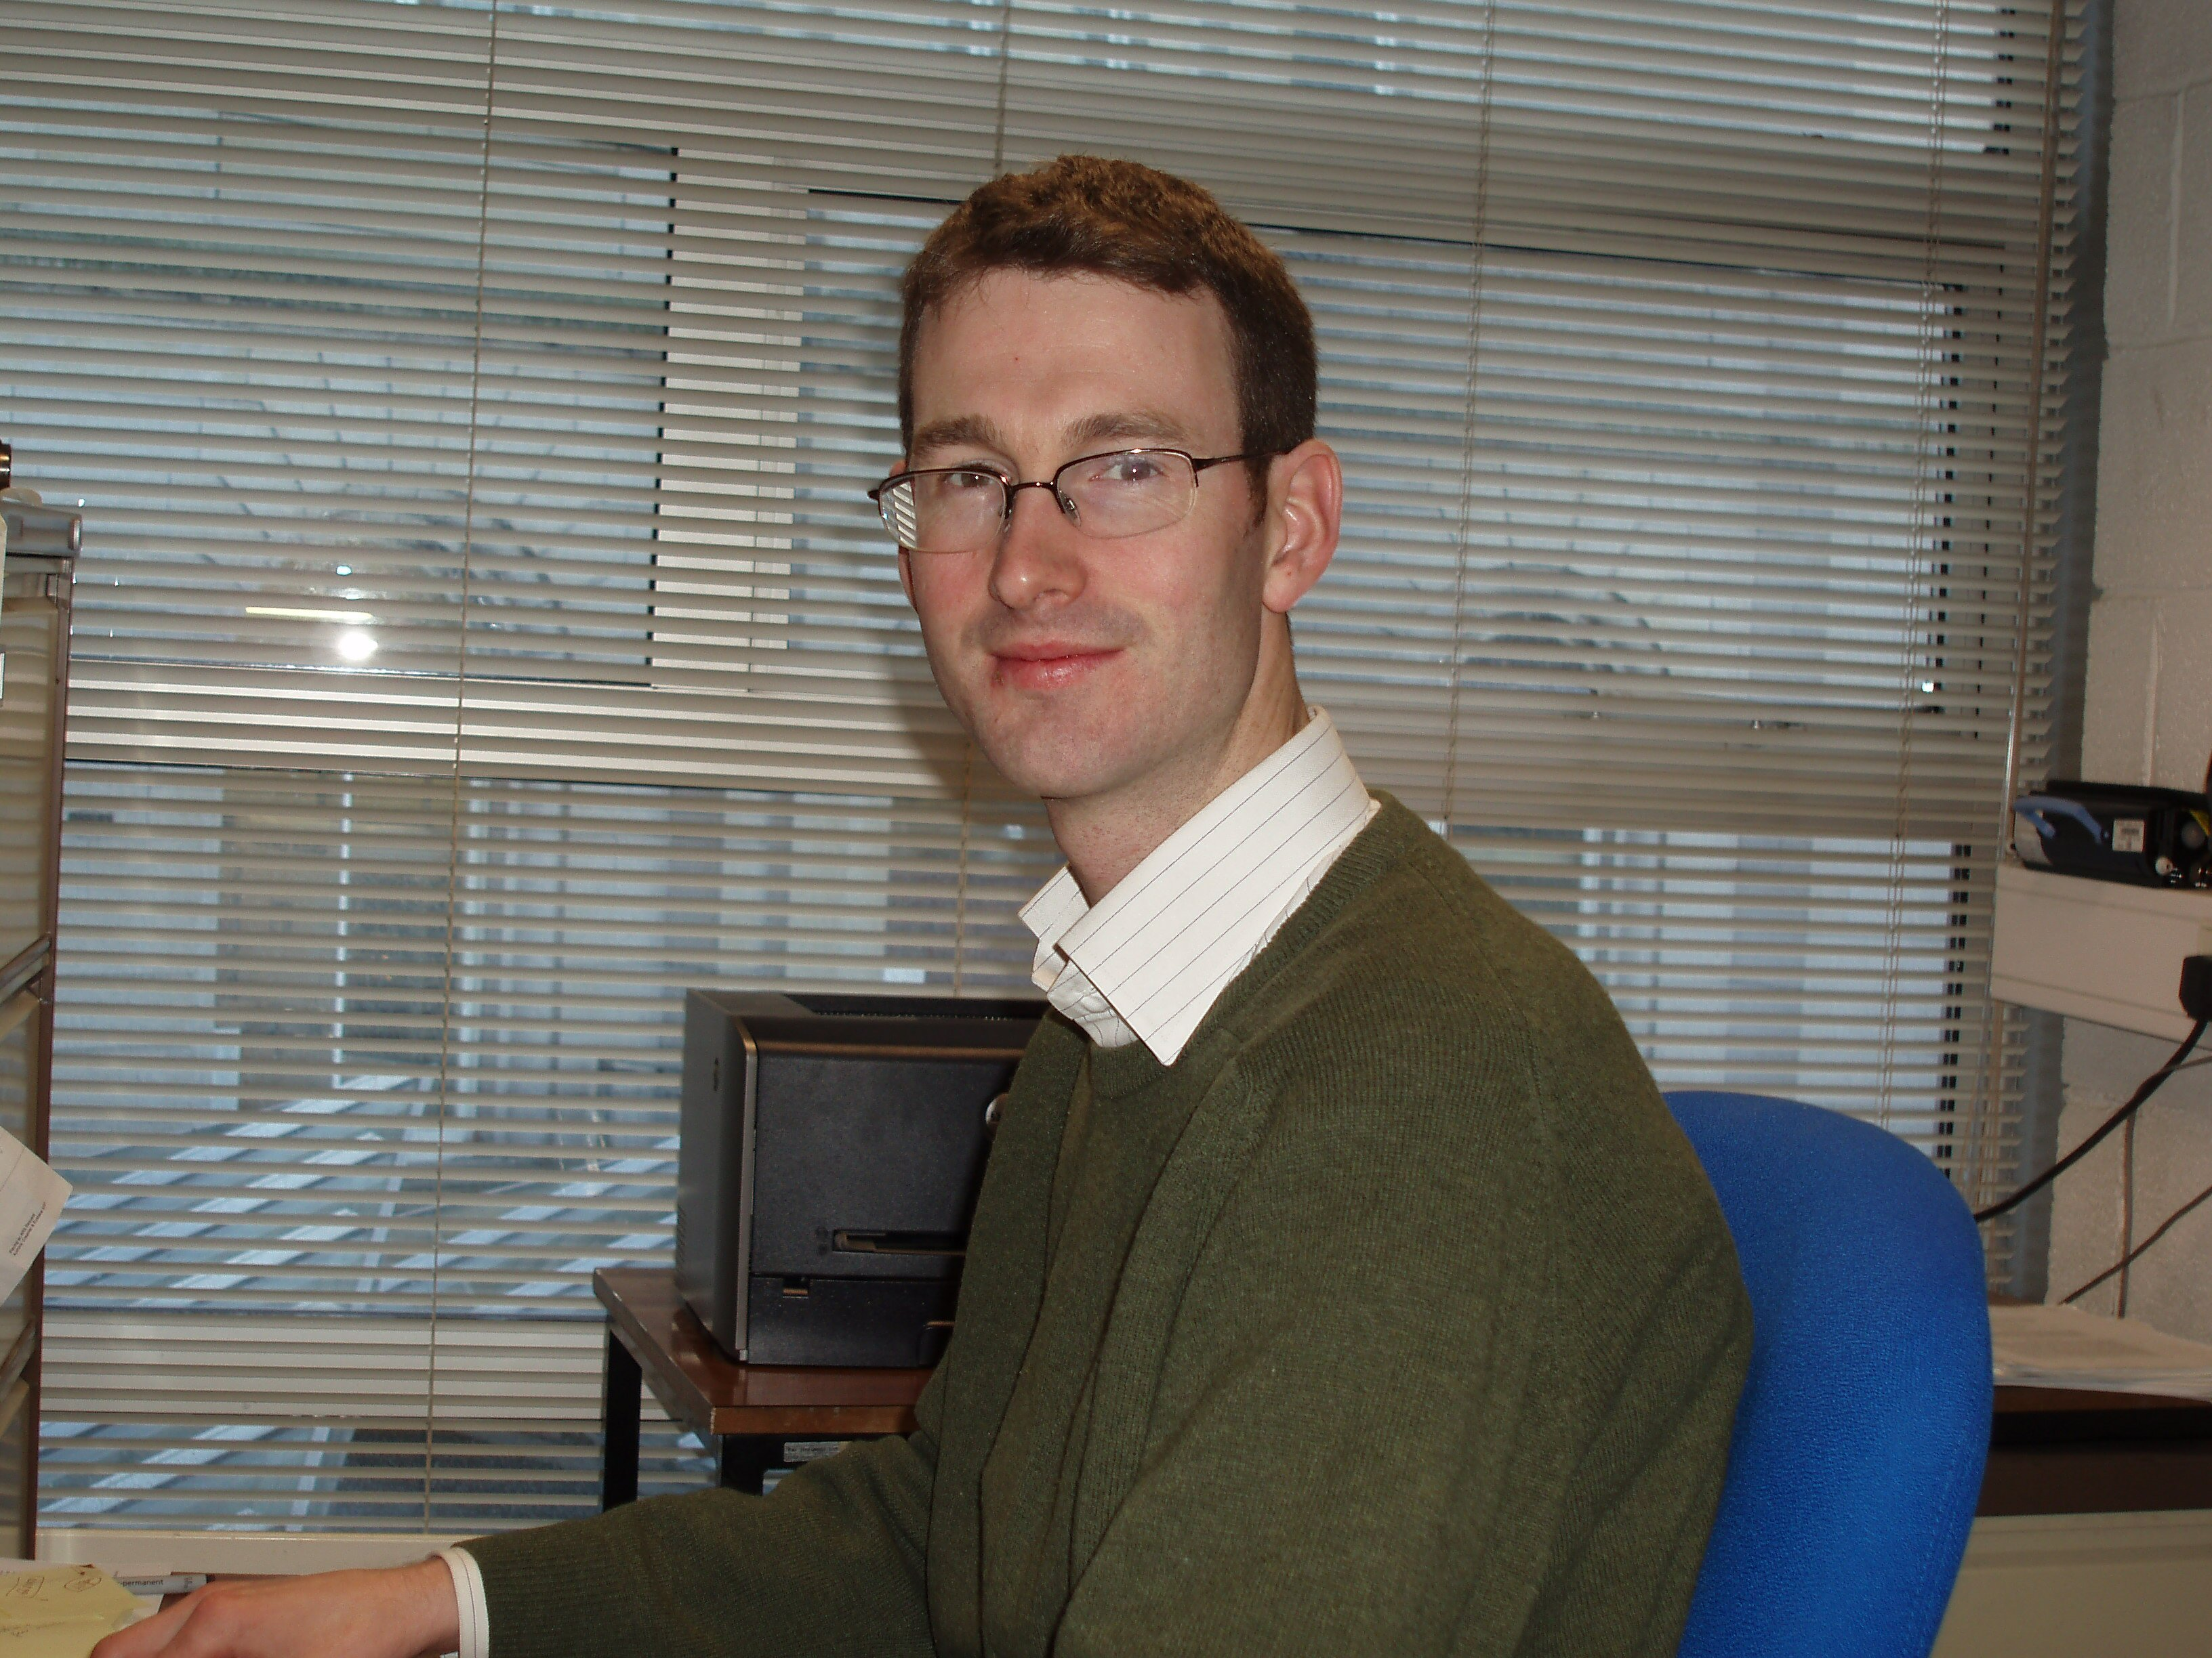

**Professor Ciaran Simms**

## Associate Professor, Mechanical & Manufacturing Engineering

Ciaran Simms, BA, BAI, PhD, FTCD, MIEI is Associate Professor in the Department of Mechanical and Manufacturing Engineering at Trinity College Dublin with research expertise in impact biomechanics and soft tissue mechanics and device design. He is also a Principal Investigator in the Centre for Bioengineering in Trinity College, Dublin. He is the Director of Undergraduate Teaching and Learning in the School of Engineering.

Prior to joining TCD as an academic staff member in 2001 he held research engineer positions with TNO Automotive in Delft and Detroit and with Denis Wood Associates Forensic Investigators in Dublin.

His principal area of interest lies in human body modelling for injury prevention. This began with mainly experimental models of the head, neck and jaw for his PhD thesis and progressed to computational modelling through work with the Dutch Research Corporation TNO in Delft, The Netherlands and Detroit, USA. His ambition is to develop a suite of global human body models applied to protective equipment optimization in the fields of pedestrian and cyclist protection, wheelchair user transportation and sports accident biomechanics.

He has a well-established teaching and research programme in the areas of mechanics and biomechanics focussed on pedestrian, cyclist and wheelchair user transport safety, soft tissue mechanics, sports injury biomechanics and device design. He has written over 50 Journal papers which have generated over 1000 Google scholar citations, and he has an h-index of 18. He has written the only textbook on the biomechanics of pedestrian and cyclist impact, and he is President of the International Research Council on the Biomechanics of Injury (IRCOBI) and soft tissue editor of the Elsevier Journal of Mechanical Behaviour of Biomedical Materials.

Ciaran has research funding from diverse sources, including Science Foundation Ireland, the Irish Health Research Board, the European Union, the National Roads Authority of Ireland, Intergrade Ireland and Enterprise Ireland. He has academic collaborations in Ireland, Europe, the US and Asia. He has commercial collaborations with industrial partners in Ireland (North and South).