Certificate in Traffic Medicine
Autumn 2018

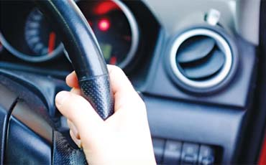
Contents
RCPI Certificate in Traffic Medicine 3
Course details 3
Proposed Timeline 3
Learning outcomes 3
Format 4
Target audience 4
Course co-ordinator 4
14 CPD Credits awarded by the Royal College of Physicians of Ireland 4
Workshop Timetable TBC 5
Certificate in Traffic Medicine 5
Workshop 5
CERTIFICATE IN TRAFFIC MEDICINE 6
SPEAKER BIOGRAPHIES Workshop (Speaker line-up for workshop TBC) 6
Professor Des O’Neill 6
Dr Declan Whelan 7
Dr Tadhg Stapleton 7
Dr Eugene Wallace 8
Mr Tony Regan 9
Dr Declan Bedford 9
Professor Ciaran Simms 10

RCPI Certificate in Traffic Medicine
This blended learning course includes online tuition, a face-to-face workshop and an online Multiple-Choice Question exam.

Course details
The Certificate in Traffic Medicine will be awarded based on the completion of all components of the course, which take approximately 14 hours to complete.
Pre-Course Videos | Workshop | Post-Course Examination
Online (5 hrs.) | One-Day (7 hrs.) | Online (2 hrs.)

Proposed Timeline
Registration Opens: August 20th
Online Components: Self-paced from August 23rd, 2018
Workshop Date: Workshop-Thursday November 8th
Online Exam: Self-paced November 9th – 30th
Registrations Close: October 31st

Cost: €400

Course Description
This programme was developed by the RCPI and the RSA with the aim of introducing health professionals to this important and growing area of practice. It is designed to give you a better understanding of the role of the clinician in assessing fitness to drive, working as part of a multidisciplinary team. The course will also introduce you to the concepts of traffic medicine, the psychology of driver behaviour and will give you a knowledge and understanding of a thorough assessment of fitness to drive. The programme reflects the principles outlined in the Sláinte agus Tiomáint Medical Fitness to Drive Guidelines (2018).

Learning outcomes
On completion of this Certificate, participants will be able to:
- Effectively assess a patient or client's fitness to drive in their own clinical setting
- Participate in complex decision-making as part of a multidisciplinary team
- Outline the necessary elements of a thorough assessment of fitness to drive for Group 1 and 2 license holders
- Integrate elements of physical and cognitive assessment with theories of driver behaviour
- Describe the role of the RSA, guidelines for assessing fitness to drive (Sláinte agus Tiomáint) and the RSA Strategy
- Demonstrate a thorough and efficient approach to assessing fitness to drive
- Apply current best-practice guidelines to the assessment, documentation and communication of fitness to drive decisions
- Manage complex challenges and conflicts in decisions affecting a patient's fitness to drive.

Format
This is a blended learning course whereby the first section is delivered online and the second section is a practical workshop. Participants must complete the online section before attending the workshop.
This one-day workshop is delivered as lectures which will focus on the practical skills and complex decisions involved in assessing medical fitness to drive. It will be integrated with case-based discussions and problem-solving sessions.

Target audience
All medical and healthcare professionals.

Course Registration
To find out more or book online go to;
https://www.rcpi.ie/store/2018-certificate-in-traffic-medicine

Course co-ordinator
notm@rcpi.ie

14 CPD Credits awarded by the Royal College of Physicians of Ireland

Workshop Timetable TBC

Certificate in Traffic Medicine

Workshop
Thursday 8 November, 2018. Venue: RCPI, Setanta House., Dublin 2
Time | Topic | Speaker
09.00-09.30 | Registration with Tea & Coffee (Connor Ward Room)
Session I Chair: Prof Des O’Neill (Geoffrey Bourke Room)
09.30-09.40 | Introduction and Welcome | Prof Des O’Neill
09.40-10.00 | Traffic Medicine and On-Road Assessment | Mr. Tony Regan
10.00-11.00 | Assessment of Fitness to Drive
 | · Group One – Conor Ward Room | Dr Tadhg Stapleton
 | · Group Two – Geoffrey Bourke Room | Dr Declan Whelan
11.00-11.30 | Tea & Coffee Break (Connor Ward Room)
11.30-12.30 | Assessment of Fitness to Drive
 | · Group One – Geoffrey Bourke Room | Dr Declan Whelan
 | · Group Two – Conor Ward Room | Dr Tadhg Stapleton
12.30-13.15 | Lunch with Tea & Coffee (Connor Ward Room)
Session II Chair: Dr Declan Bedford (Geoffrey Bourke Room)
13.15-13.45 | Case Based Discussions | Dr Eugene Wallace
13.15-13.45 | Case Based Discussions | Mr. Tony Regan
13.45.14.00 | Change Planning, Summary | Prof Des O’Neill
14.15 -14.30 | Questions and Answers | Prof Des O’Neill (Chair)
14.30-14.45 | Tea & Coffee Break (Connor Ward Room)
14.45-15.15 | Positive Interventions | Prof Des O’Neill
15.15-16.30 | Problem Solving in Adaptive Technologies | Dr Ciaran Simms
16.30-16.45 | Questions and Answer | Dr Declan Bedford (Chair)
16.45 -16.55 | Closing remarks | Dr Declan Bedford

CERTIFICATE IN TRAFFIC MEDICINE

SPEAKER BIOGRAPHIES Workshop (Speaker line-up for workshop TBC)

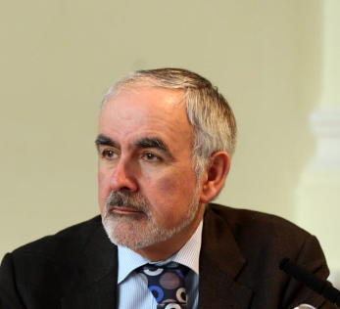

Professor Des O’Neill

Consultant Geriatrician National Programme Director for Traffic Medicine

Professor Desmond O’Neill, Consultant Physician in Geriatric and Stroke Medicine at Tallaght Hospital Dublin and Trinity College Dublin and Director for the National Programme Office for Traffic Medicine RCPI/RSA.

Professor O’Neill graduated from Trinity College Dublin (TDC). He trained as a geriatrician in St James's Hospital and the University of Bristol. Following an appointment as consultant geriatrician in Selly Oak Hospital, Birmingham he returned to Dublin and currently is the senior academic in Medical Gerontology at the TCD campus at Tallaght Hospital.

His major field of research is that of transportation, ageing and older drivers. He co-chaired the RCPI Working Group on Driving and Health and has written chapters on driving and health for three international textbooks of geriatric medicine, two international textbooks of dementia care, two textbooks of medical ethics, and an Irish textbook of geriatric medicine. In addition, he was co-author of a major OECD report on transport in later life and contributed to a similar report for the US Transportation Research Board.

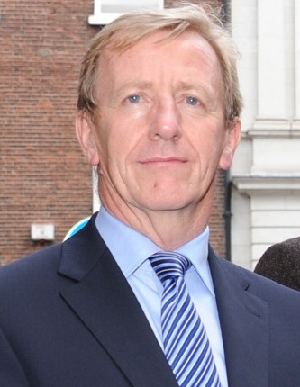

Dr Declan Whelan

Dean of the Faculty of Occupational Medicine, RCPI

Declan Whelan is a UCD graduate (class ’78) and is Chief Medical Officer to the CIE Group of companies, providing a comprehensive Occupational Health Service to some 12,000 transportation employees. Dr Whelan is also a Member and former Secretary of the Board of the International Union of Railway Medical Services.
He is a Fellow of the Royal College of Physicians of Ireland and a Fellow of the Faculty of Occupational Medicine RCPI. He is currently Vice Dean to the Faculty of Occupational Medicine as well as serving as a Trainer and Examiner for the Faculty. Dr Whelan is the Chairman of the RCPI Working Group tasked with developing Medical Guidelines on Fitness to Drive for Ireland in conjunction with the National Programme Office for Traffic Medicine. He is also a Member and Treasurer to the local organising committee for the International Congress of Occupational Health (ICOH) Dublin 2018 conference.

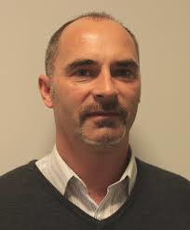

Dr Tadhg Stapleton

Assistant Professor in Occupational Therapy, Trinity College Dublin

Dr Tadhg Stapleton is currently working as Assistant Professor in Occupational Therapy at Trinity College Dublin, Ireland. His clinical occupational therapy experience has primarily been in the area of adult neurological rehabilitation and older adult rehabilitation in both hospital and community settings. His research interests span a range of occupational therapy practice, and his publications include clinical based research on stroke, multiple sclerosis, rheumatoid arthritis, and outcome measurement use among occupational therapists.
His principle area of research is related to occupational therapy involvement in the clinical assessment of fitness to drive among people with stroke and older adults. He completed his
PhD at Trinity College Dublin and the focus of the study was on the process of assessing fitness to drive after stroke within an Irish context of practice. He completed postgraduate training as an Occupational Therapy Driving Assessor at La Trobe University Melbourne.
He is the AOTI representative to the National Programme Office for Traffic Medicine [joint Royal College of Physicians of Ireland (RCPI) and the Road Safety Authority (RSA)] and contributed to the development and delivery of the RCPI Post Graduate Certificate in Traffic Medicine.
Dr Stapleton was awarded a Health Research Board Knowledge Exchange and Dissemination Scheme Grant in 2013 to deliver training programmes for occupational therapists on addressing driving issues in their clinical practice. Three 2-day training programmes were delivered in 2013 and 2014 with 122 occupational therapists completing the course. He is working closely with several hospital-based occupational therapy services in developing fitness to drive assessment pathways and is also coordinating a pilot project developing a driving screening pathway with community/primary care occupational therapists in the Dublin Mid Leinster region.

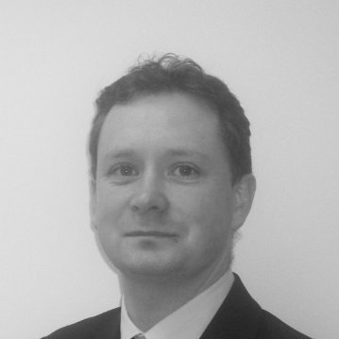

Dr Eugene Wallace

Consultant in Rehabilitative Medicine

Dr Eugene Wallace works as a consultant in Rehabilitation at the National Rehabilitation Hospital and St, James Hospital, Adelaide and Meath Hospital (incorporating National Children's Hospital). Dublin. Previously he worked in St. James Hospital Foundation, Southern General Hospital, Glasgow and the National Rehabilitation Hospital, Dublin.
Eugene completed his Specialist Registrar Training in Rehabilitation Medicine in July 2013
and is currently undertaking Medical Doctorate Research into the rate and pattern of cerebral oedema formation post cardiac arrest. Eugene completed his General Professional Training with General (Internal) Medicine, RCPI 2007 and became a Member of the Royal College Physicians of Ireland (MRCPI), RCPI in 2008 and in 2013 achieved European Physical & Rehabilitation Medicine Board Certification, UEMS (Union Européenne des Médecins Specialistes). Euegene has a Diploma in Cerebrovascular & Stroke Medicine, RCPI 2012. And has a special interest in research in Spinal Injuries, Neurorehabilitation and in Prosthetics Rheumatology.

- 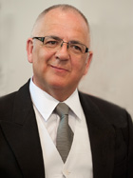

Mr Tony Regan

On-road Driving Assessor and advisor on mobility issues

Tony Regan has over thirty years experience in working with driving and transport assessment for older and disabled people. He has worked at mobility centres in Belfast, Great Britain, Boston USA and Cleveland Ohio and was the Driving Advisor at the UK Department of Transports’ MAVIS Mobility Centre from 1985 to 1990. He is certified in Assessment from the ADED USA, and currently a member of ADED. Tony is currently completing an MSc in Driving Assessment and Outdoor Mobility with the UK Forum and Chester University.
Since his return to Ireland in 1993 Tony has worked for the Disabled Drivers Association of Ireland and the Irish Wheelchair Association before setting-up his own consultancy business, Transport and Mobility Consultants Ireland. He was a founder member of the UK Forum of Mobility Centre, the Association of Driver Educators for People with Disabilities, and is currently a member of the Chartered Institute of Logistics & Transport in Ireland, and he has certification in assessing and teaching people with disabilities to drive.

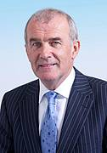

Dr Declan Bedford

Consultant in Public Health Medicine and Chair of RCPI Working Group in Traffic Medicine

Dr Declan Bedford is a Fellow of the Faculty of Public Health Medicine of the RCPI. He worked as a Specialist in Public Health Medicine with the HSE and as Director of Public Health in the North East for seven years until his retirement from the HSE in August 2012. He now works for several agencies including the RCSI where his role is to support the strategic development of the RCSI Hospitals Group. He is currently chairman of the RCPI Working Group on Traffic Medicine and chairman of the Health Research Board
His published research includes research in the areas of suicide and mental health, men’s health, alcohol, injury prevention, infectious diseases, health services and utilisation of hospital services.

Professor Ciaran Simms

Associate Professor, Mechanical & Manufacturing Engineering

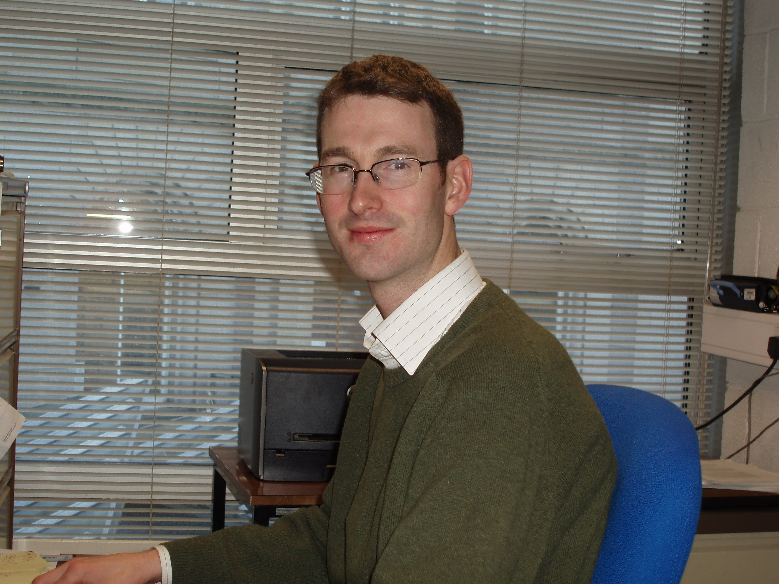
Ciaran Simms, BA, BAI, PhD, FTCD, MIEI is Associate Professor in the Department of Mechanical and Manufacturing Engineering at Trinity College Dublin with research expertise in impact biomechanics and soft tissue mechanics and device design. He is also a Principal Investigator in the Centre for Bioengineering in Trinity College, Dublin. He is the Director of Undergraduate Teaching and Learning in the School of Engineering.
Prior to joining TCD as an academic staff member in 2001 he held research engineer positions with TNO Automotive in Delft and Detroit and with Denis Wood Associates Forensic Investigators in Dublin.
His principal area of interest lies in human body modelling for injury prevention. This began with mainly experimental models of the head, neck and jaw for his PhD thesis and progressed to computational modelling through work with the Dutch Research Corporation TNO in Delft, The Netherlands and Detroit, USA. His ambition is to develop a suite of global human body models applied to protective equipment optimization in the fields of pedestrian and cyclist protection, wheelchair user transportation and sports accident biomechanics.
He has a well-established teaching and research programme in the areas of mechanics and biomechanics focussed on pedestrian, cyclist and wheelchair user transport safety, soft tissue mechanics, sports injury biomechanics and device design. He has written over 50 Journal papers which have generated over 1000 Google scholar citations, and he has an h-index of 18. He has written the only textbook on the biomechanics of pedestrian and cyclist impact, and he is President of the International Research Council on the Biomechanics of Injury (IRCOBI) and soft tissue editor of the Elsevier Journal of Mechanical Behaviour of Biomedical Materials.
Ciaran has research funding from diverse sources, including Science Foundation Ireland, the Irish Health Research Board, the European Union, the National Roads Authority of Ireland, Intergrade Ireland and Enterprise Ireland. He has academic collaborations in Ireland, Europe, the US and Asia. He has commercial collaborations with industrial partners in Ireland (North and South).

