SAVE THE DATE

Joint UKISCRS Cataract & Refractive Surgery Meeting
&
Mr Peter Barry Memorial Meeting

and Mr Peter Barry Memorial Lecture

Thursday 28th November 2019 - 9-4.30pm
Education & Conference Centre
Royal Victoria Eye & Ear Hospital,
Adelaide Road, Dublin 2

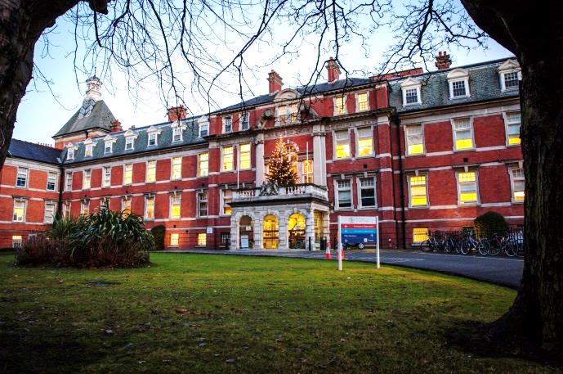

Please RSVP to: Registration Fee: €200.00
Sterling: £180.00
Cathy Fox
Department of Ophthalmology
RCSI, RVEEH
Tel: 003531 6343659
E-mail: cathy.fox@rveeh.ie

SAVE THE DATE
Joint UKISCRS Cataract & Refractive Surgery Meeting
&
Mr Peter Barry Memorial Meeting
Medal Lecture
by Professor Rudy Nuijts
Professor of Ophthalmology, University of Maastricht

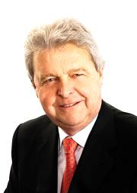

Thursday 28th November 2019 - 5-7pm
Education & Conference Centre
Royal Victoria Eye & Ear Hospital,
Adelaide Road, Dublin 2

