NEW FRONTIERS IN OPHTHALMOLOGY
Thursday 22 June 2023
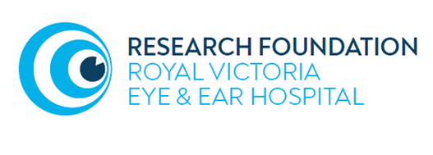

Registration 8.30 Tea & Coffee PROGRAMME
9.00AM | Welcome and Introduction from Chair Mr Michael O’Rourke
9.15 -09.30 | A Standard approach to the ptosis history and examination  Dr Qirat Qurban. Oculoplastics Fellow, Royal Victoria Eye and Ear Hospital Dublin
9.30 – 10.00 | Variables in Adult Ptosis Repair  Prof Alan McNab. Orbital, Plastic and Lacrimal Clinic, Royal Victorian Eye and Ear Hospital, Melbourne, Australia
10.00 – 10.30 | Paediatric Ptosis – no frills  Dr Tom Hardy. Orbital, Plastic and Lacrimal Clinic, Royal Victorian Eye and Ear Hospital, Melbourne & Royal Children’s Hospital Melbourne, Australia
10.30 -11.00 | Red flags in ptosis: how to avoid missing the neurologically unmissable  Dr Duncan Rogers. Neuro-ophthalmology specialist, Grangegorman Primary care Centre & Mater misericordiae University Hospital, Dublin
11.00 – 11.30 | Tea/Coffee Break
11.30 – 12.00 | Functional and aesthetic treatment of the periocular area: what the general ophthalmologist needs to know.  Ms Rizwana Khan. Oculoplastic & Orbital specialist. Royal Victoria Eye and Ear Hospital Dublin & Hermitage Clinic, Dublin
12.00 -13.00 | Grand rounds: Ptosis, pseudoptosis or other – should I cut or investigate?  Cases submitted an discussed by a panel from the Irish Oculoplastics Forum.  Moderator: Mr Michael O’Rourke
13.00 – 14.00 | Break for Lunch

