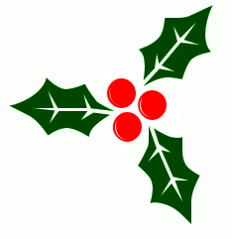OPHTHALMIC POSTGRADUATE TEACHING PROGRAMME 2015-2016.
THIS MEETING IS MANDATORY FOR ALL TRAINEES
Christmas Ophthalmology Quiz

Mr Noel Horgan
Consultant Ophthalmic Surgeon, Royal Victoria Eye & Ear Hospital

Thursday 8th December 2016, 5-6pm

5.00: Introduction: Dr Denise Curtin
Chair: Mr Noel Horgan

5.30: Christmas Quiz ** Prizes up for grabs**

6.00: Wine & finger food reception

This meeting is kindly sponsored by:

Refreshments will be available from 4.30. The meeting will begin at 5pm sharp.

Future Post Graduate Teaching dates for your diary:
2017

January 19th Professor Stefan Seregard, Karolinska Insitute, Stockholm
Consultant in Ophthalmic Pathology & Oncology
“Ophthalmology the day after Tomorrow”

February 16th Dr Susan Knowles,
Consultant Microbiologist, RVEEH & NMH, Holles St.
“Ocular Infections in the Dry Eye”

