

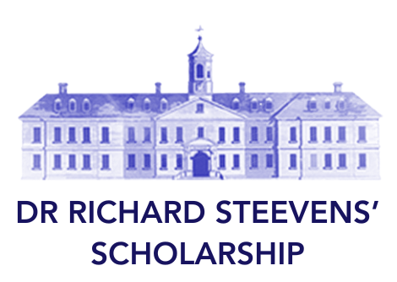

Guide for Applicants
for SpR/SR Training Overseas
2027

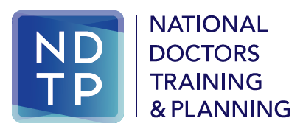
The Dr Richard Steevens’ Scholarship
The scholarship was established by the Health Service Executive (HSE) in 2007, arising from a recommendation of the Report of the Postgraduate Medical Education and Training Group.
This important initiative provides a valuable opportunity for specialist medical trainees to spend time training in centres of excellence abroad and to bring the clinical skills gained back to the Irish health service.
The programme is aimed at supporting clinical training as distinct from research. It is particularly targeted at Specialist Registrars /Senior Registrars, who are in the latter stages of their Higher Specialist Training (HST) programme, in order to maximise the benefit of specialised training abroad.

The 2027 Call for Applications
The HSE is now inviting applications for the Dr Richard Steevens’ Scholarship for positions commencing in July 2027. Applications from all specialty areas will be considered for eligible applicants.
Additionally, the HSE will look favourably upon areas which have not been funded previously (details of previous awards can be found on the NDTP website).
Applications should focus on the acquisition of particular identified training for which opportunities are limited or unavailable in Ireland, which are relevant to the Irish health service and which will benefit future patient care in Ireland.
The HSE envisages that up to four Scholarships will be awarded. In cases where the successful applicants have some financial support from their host institution or other source, this will be offset against the scholarship.
Applications must be submitted by e-mail to the relevant Postgraduate Medical Training Body by 30th October 2026.

Who Should Apply

Applicants must be in the latter stages of Higher Specialist Training (within two years of CSCST at July 2027) and enrolled with the relevant Postgraduate Medical Training Body. The Scholarship is available to be taken in the last year or second last year of HST.

Applicants must have undertaken all of their SpR training in clinical posts in Ireland at the time of application, in other words the Dr Steevens’ Scholarship year would be recognised by the training body as the out-of-programme year.

The programme is aimed at outstanding trainees with a proven track record in achievement.
Please note, those trainees who will be receiving their CSCST during the fellowship are not eligible to apply.
How to Apply

Applicants must apply through their recognised Postgraduate Medical Training Body, please contact them for details of how to submit your application. The application must include the following:

- Completed Applicant’s Coversheet (typed - not hand-written).

- A letter outlining the rationale for applying, the specific skills/training that will be obtained, the learning objectives, novelty of the area and details of how the skills obtained will be utilised on return to Ireland.

- Written confirmation from the proposed clinical supervisor/host institution confirming that a placement will be facilitated and confirming what (if any) bursary/funding is available from the host institution or any other source.

- Curriculum Vitae, outlining all outstanding clinical and academic achievements to date.

Applications will be accepted through the following Training Bodies:
- College of Anaesthesiologists of Ireland (CAI)
- Irish College of General Practitioners (ICGP)
- Irish College of Ophthalmologists (ICO)
- Irish Committee for Emergency Medicine (ICEMT)
- College of Psychiatry of Ireland (CPI)
- Faculty of Occupational Medicine, RCPI
- Faculty of Paediatrics, RCPI
- Faculty of Pathology, RCPI
- Faculty of Public Health Medicine, RCPI
- Institute of Obstetricians & Gynaecologists, RCPI
- Institute of Medicine, RCPI
- Faculty of Radiologists, RCSI
- Irish Surgical Postgraduate Training Committee, RCSI

Please note that applications made directly to the HSE will not be accepted.

The Selection Process
Stage 1 - Training Body Shortlisting
Each Training Body will consider the applications submitted to it and shortlist the applications. Consideration will include:
- The track record and future potential of the candidate
- The proposed area of training and whether such training is or is not available in Ireland
- The proposed area of training and whether gaps exist in the Irish health service
- The suitability of the host institution
Each Training Body will be permitted to submit up to four (4) applications to the HSE.
All application documents for shortlisted candidates will be forwarded by the Forum of Irish Postgraduate Medical Training Bodies to the HSE’s Medical Education & Training Unit in NDTP for consideration.
The Training Bodies will inform candidates of the outcome of this stage of the process, by mid-November 2026.
Stage 2 - HSE Selection
The HSE will form an expert advisory panel to assess the applications, and may seek specific advice from relevant experts, Clinical Directors etc. as required. The principal considerations will be:
- The potential benefits to the Irish health service and patients of sponsorship of the proposed area of training

- Identified unmet patient need
- Specialty and service priorities
- Unavailability or limited availability of such training in Ireland
- The calibre of the applicant and demonstration of future potential
- Appropriateness of proposed training to the candidate’s level of training
- An area of training which has not been funded previously
The HSE will inform candidates of the outcome of the selection process by the end of December 2026.

The Award
Successful candidates will be awarded the Dr Richard Steevens’ Scholarship and will receive their salary for the duration of the Scholarship. The salary will be based on the applicant’s current point on the SpR/SR salary scale at the time of commencement.
Other costs, such as travel, visas, living expenses etc. are a matter for the recipient of the Scholarship.
Details of the mechanism for payment will be provided to successful applicants. Successful recipients will be required to sign an Award Agreement with the HSE.

Conditions of the Award
- Placements must be for a minimum of 3 months’ duration and up to a maximum of 12 months’.
- The sponsored period of training must be undertaken within the duration of the SpR/SR training scheme and prior to award of CSCST.
- Successful applicants must continue to be enrolled with their Training Body for the duration of the Scholarship.
- Placements must be at recognised centres of excellence in the particular specialty area.
- Placements must be completed within the timeframe July 2027 - July 2028 and deferrals are not possible under the scholarship.
- Note that the employment relationship will be with the host site and local arrangements for employment at the host institution should be made by the recipient directly with their host institution.
- Where appropriate, recipients of the Scholarship are obliged to return to Ireland to complete their higher specialist training.
- The primary focus of this placement must be clinical skill development as distinct from research activities.
- Arrangements for local registration/licensing is a matter for the individual applicant.
- Applicants must have undertaken all of their SpR training in clinical posts in Ireland at the time of application, in other words the Dr Steevens’ Scholarship year would be recognised by the training body as the out-of-programme year.

